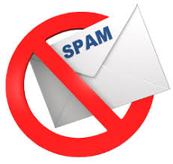

**TEAM ID: NM2023TMID16418**

**TEAM SIZE: 4**

**1. M. Nagapooja (TEAM LEADER)**

**2. P. Shanmathi (MEMBER 1)**

**3. M. Parkavi (MEMBER 2)**

**4. R. Kalishwari @ Devi (MEMBER 3)**

**III – B.Sc COMPUTER SCIENCE (Shift – I)**

**RANI ANNA GOVERNMENT COLLEGE FOR WOMEN,**

**TIRUNELVELI – 8.**

**1.INTRODUCTION**

**1.1 Overview**

Spam is **any kind of unwanted, unsolicited digital communication that gets sent out in bulk**. Often spam is sent via email, but it can also be distributed via text messages, phone calls, or social media.

In machine learning, spam filtering protocols use instance-based or memory- based learning methods to identify and classify incoming spam emails based on their resemblance to stored training examples of spam emails.

**1.2 Purpose**

A Spam filter is a program used to detect unsolicited, unwanted and virus-infected emails and prevent those messages from getting to a user’s inbox

Spam filters are important features for Effective and

Safest communication..

Spam emails are almost always commercial and driven by a financial motive. Spammers try to promote and sell questionable goods, make false claims and deceive recipients into believing something that's not true. The most popular spam subjects include the following: pharmaceuticals.

**2. PROBLEM DEFINITION & DESIGN THINKING**

**2.1**  **Empathy Map**

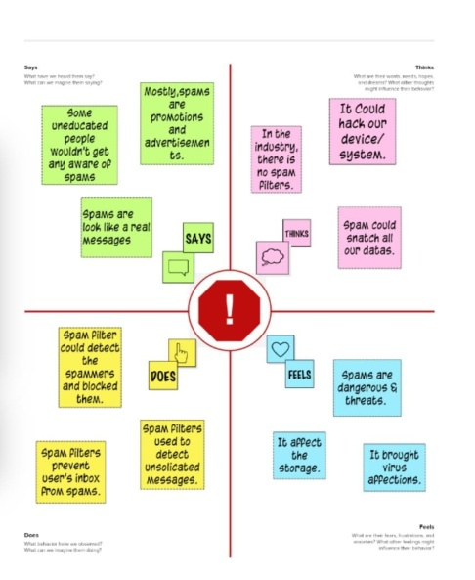

**2.2 Ideation & Brainstorming Map**

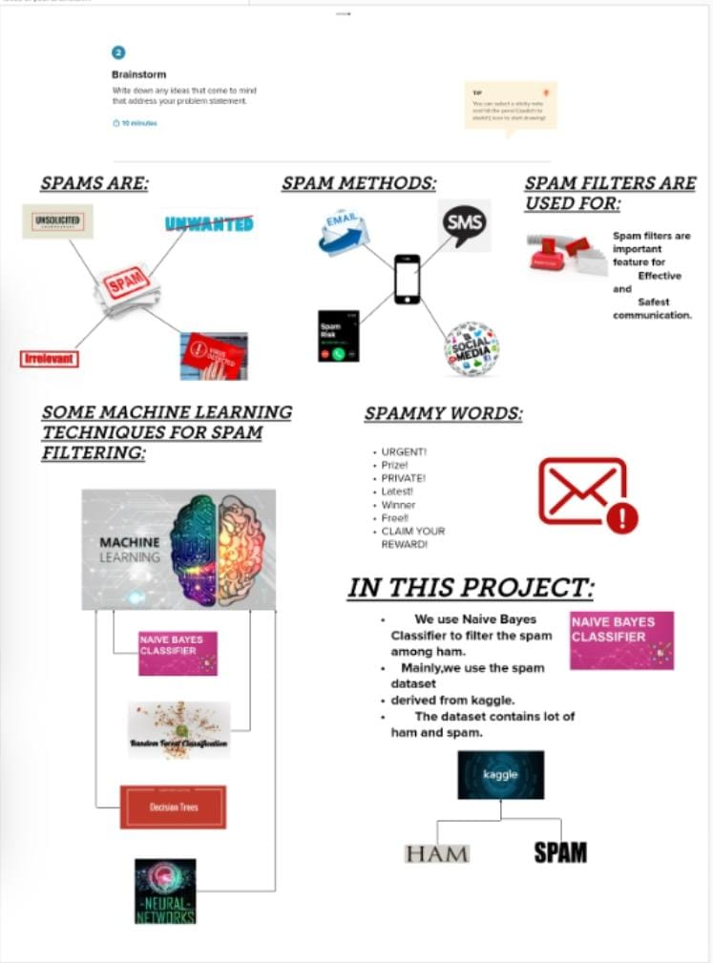

**3. RESULT**

Final findings of the project is an entered message was whether spam or ham, the alert message was displayed in the predicted result webpage.

If the message is spam , the result would display like a alert message “SPAM”.

If the message is not spam , the result would display “HAM”.

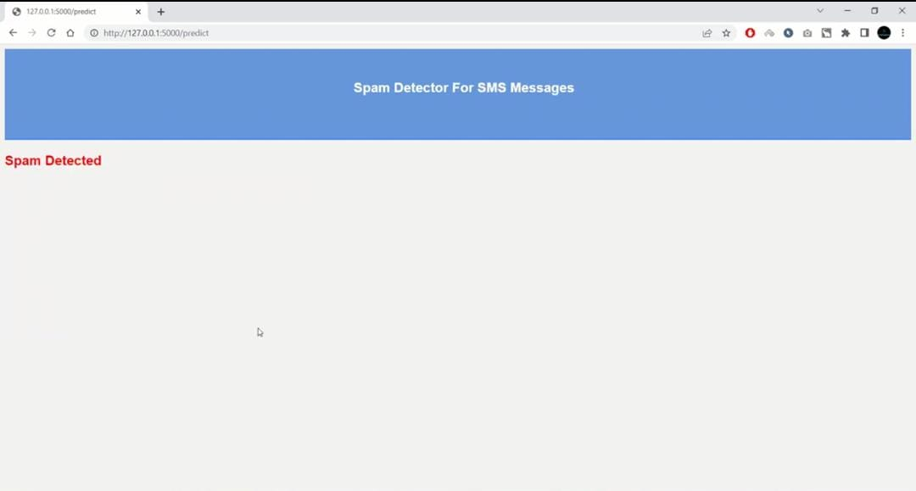

**4. ADVANTAGES & DISADVANTAGES**

**Advantages:**

An email spam filter is a tool used in email hosting software that churns out unsolicited, unwanted, and virus-infested emails and keeps such emails off of the user's inbox.

This **protects the user from any potential cyber threat and facilitates smooth communications and workflow**.

**It Streamlines Inboxes**

**Protect Against Malware**

**Keeps You Compliant**

**It Saves You Money**

**Disadvantages:**

Thousands of spam emails may reach Inboxes before a spammer's email address, IP or domain is blacklisted.

Spam filtering is machine-based so there is a room for mistakes called “false positives.”

In my opinion spam mails are good they will take us to a world that we never have been.

But some people think that the internet lost its purity.So they complained about spam to their ISP and force them to take further action against the spam.

These kinds of actions make serves to dual check for privacy and use highly encrypted lines for any communication.

Most ISP’s are now providing filters to catch spam mails.

**5. APPLICATIONS**

Often, an internet service provider (ISP) will use spam detection to reduce the amount of spam delivered to users. Companies can do the same to lessen the burden of spam on their employees. However, spam filtering can also flag legitimate emails from companies users actually want to get messages from.

**6. CONCLUSION**

In this paper the existing spam detection techniques, their current applications and their limitations have been highlighted. It has been seen that even the existing techniques consist of certain loop holes and none of the methods is completely effective in itself. Review spam detection is indeed a hard task but it requires continuous research and development in this field.

**7. FUTURE SCOPE**

Review spam detection is essential since it can ensure justice for the sellers and retain the trust of the buyer on the online stores. The algorithms developed so far have not been able to remove the requirement of manual checking of the reviews.

Hence there is scope for complete automation of spam detection systems with maximum efficiency. With growing popularity of online stores, the competition also increases. The spammers get smarter day by day and spam reviews become untraceable. It is necessary to identify the spamming techniques in order to produce counter algorithms

**8. APPENDIX**

**A. Source code**

**Main file**

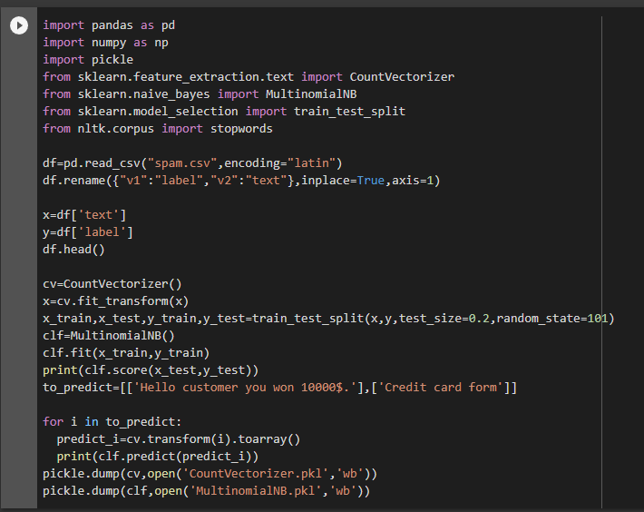

**Flask file**

